Speakers  Wholesale Prices! | Minimum Amount $1000  Email: powernetpctt@yahoo.com

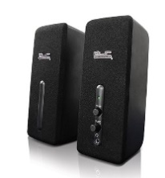 | MM220KLX13 | KES-210 | KlipX Speakers Stereo 2.0 2W | $75.00
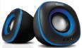 | MM220KLX18 | KES-215A | KlipX Speakers Stereo 2.0 Compact 6W Black w/Blue accent | $95.00
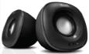 | MM220KLX19 | KES-215C | KlipX Speakers Stereo 2.0 Compact 6W Black w/Charcoal accent | $115.00
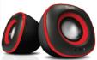 | MM220KLX20 | KES-215 | KlipX Speakers Stereo 2.0 Compact 6W Black w/Red accent | $95.00
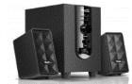 | MM220KLX32 | KES-345 | KlipX Speaker Wired 20W 2.1 SD-USB-playback 3.5mm 110/220v | $332.00
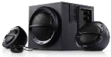 | MM220KLX15 | KES-350 | KlipX Stereo speaker 2.1 KES-350 36W USB SD playback 110/220V | $500.00
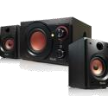 | MM220KLX14 | KES-370 | KlipX Speakers Stereo 2.1 Multimedia System w/amplifier subwoofer 38W | $530.00
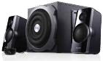 | MM220KLX16 | KES-390 | KlipX Stereo speaker 2.1 KES-390 48W remote control  110/220V | $645.00
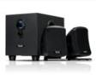 | MM220KLX11 | KSS-710 | Speakers Stereo 2.1 Multimedia System 10W | $235.00
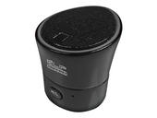 | MM220KLX22 | KWS-600 | KlipX Bluetooth Portable Rechargable Mini Speaker | $153.00  Out of stock
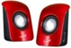 |  |  | Desktop / Laptop Speakers (Available in Red, Blue & Green) | $60.00

HEADSETS
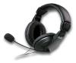 |  | KHS-300 | KlipX Headset KHS-300 Ear-cup Microphone 3.5mm Black | $127.00
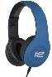 | MM500KLX17 | KHS-815BL | KlipX Headset KHS-815BK Ear-cup Microphone 3.5mm plug Blue | $127.00
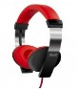 | MM500KLX19 | KHS-610 | KlipX Euforia Headset On-ear Mic Vol Ctrl 3.5mm | $127.00
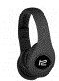 | MM500KLX12 | KHS630BK | KlipX Headset KHS-630BK Bluetooth Headset + SD  Card Slot Black | $225.00
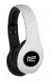 | MM500KLX13 | KHS-630WH | KlipX Headset KHS-630BK Bluetooth Headset + SD  Card Slot White | $203.00  Out of stock
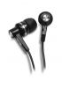 | MM110KLX71 | KSE-105BK | KlipX Sport in-ear earphone Black | $30.00
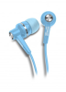 | MM110KLX76 | KSE-105BL | KlipX Sport in-ear earphone Blue | $30.00
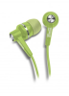 | MM110KLX75 | KSE-105GN | KlipX Sport in-ear earphone Green | $30.00
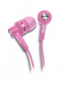 | MM110KLX74 | KSE-105PK | KlipX Sport in-ear earphone Pink | $30.00  Out of Stock
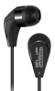 | MM110KLX73 | KSE-130 | KlipX Earphone with Mic + Answer/Hang up | $40.00
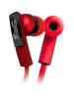 | MM110KLX83 | KHS-220 | KlipX Earphone In ear Vol-Mic sgl 3.5mm | $51.00
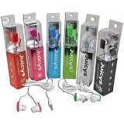 |  |  | Juicys Comfort Earbuds | $25.00

