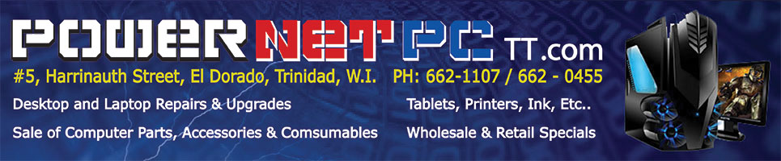
Email: powernetpctt@yahoo.com Wholesale Prices!
Tablets 01/01/2016
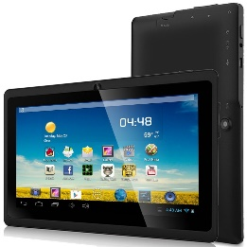
Zeepad 7” Quad Core Tablet
- Quad Core Allwinner A33 CPU 1.8GHz
- 512MB DDR3 RAM
- Built on the latest Google Android Kit Kat 4.4
- Pre-installed Apps and Games
- Bluetooth
- 4GB on board memory, with 2.8GB Free
- High Resolution 800x480 7-inch display screen
- UP to 32GB of video and music via the Micro SD slot.
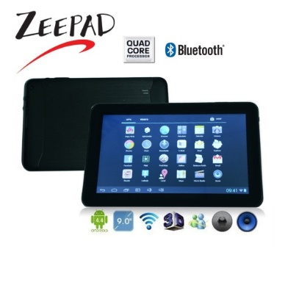
$395.00
Zeepad 9” Quad Core Tablet
- Android 4.4 KitKat
- 9 Inch Display Screen With 800x480 Resolution
- Allwinner a33 quad-core CPU arm cortex-a7 enables 4 x 1.2 GHz
- 512mb ram
- 8 GB storage Micro SD card expandable (up to 32 GB in size)
- Dual camera
- Wi-Fi (802.11b/g/n), Bluetooth OUT OF STOCK!
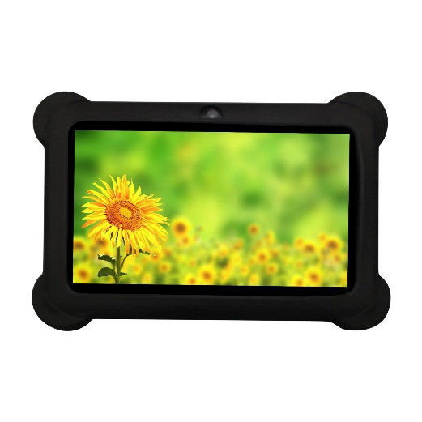
$485.00
Zeepad 7” Kids Quad Core Tablet
- Allwinner A33 Cortex A7 Quad Core 1.6GHz
- Android 4.4 KitKat
- 7 Inch Display Screen with 800 x 480 resolution
- Dual Camera
- WIFI, Bluetooth
- 512MB RAM
- 4GB of Memory(ROM) up to 32GB MicroSD
- Durable Case Holds Up against Drops and Spills
$420.00
WARRANTY IS VOID IF THERE IS ANY PHYSICAL DAMAGE TO THE PRODUCT.

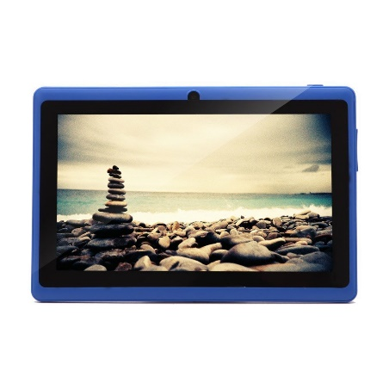
iRULU 7” Quad Core Tablet
- ARM A33 Cortex-A7 Quad core 1.5GHZ
- Mail 400 GPU
- Android 4.4 KitKat
- 7 Inch Display Screen with 1024 x 600 Resolution
- Dual Camera (Front Camera 0.3MP, Back camera 2.0MP)
- Wireless WiFi: 802.11b/g /n
- 16GB Storage up to 32GB OUT OF STOCK!
$370.00

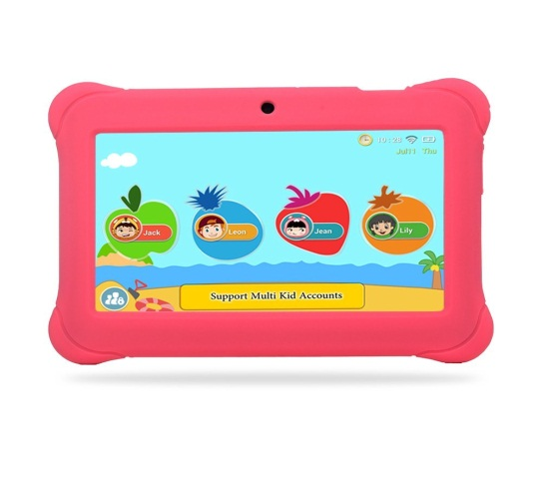
Alldaymall 7” Quad Core Tablet With Case
- Google Android 4.4 KitKat
- 7" Display Screen with 1024x600 HD Resolution
- Quad-core A33 Processor
- 8GB Nand Flash
- 1GB RAM
- Bluetooth
- 2.0MP Rear Camera, 0.3MP Front Camera
$495.00
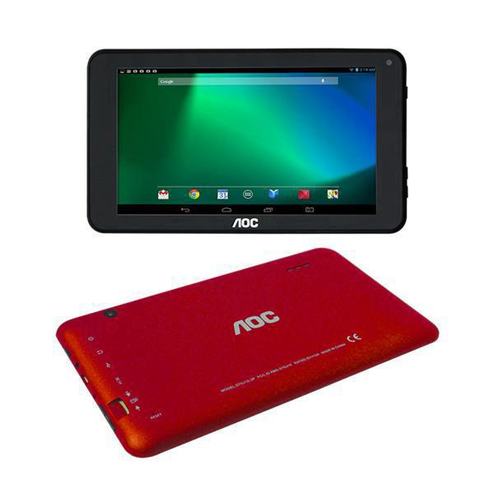
AOC 7” Dual Core Tablet
- ARM Cortex Dual core 1.0GHZ
- Android 4.4 KitKat
- 7 Inch Display Screen with 1024 x 600 Resolution
- Dual Camera (Front Camera 0.3MP, Back camera 2.0MP)
- 1GB RAM DDR3, 8GB Internal Flash
- WiFi, Bluetooth OUT OF STOCK!
$440.00

WARRANTY IS VOID IF THERE IS ANY PHYSICAL DAMAGE TO THE PRODUCT.

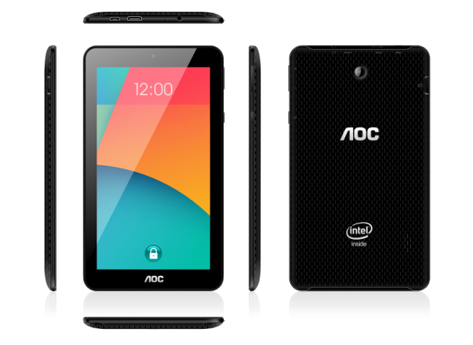
AOC 7” Quad Core Tablet
- Intel Atom Quad core 1.83GHZ Processor
- Android 4.4 KitKat
- Intel HD Graphics
- 7 Inch Display Screen with 1024 x 600 Resolution
- Dual Camera (Front Camera 0.3MP, Back camera 2.0MP) OUT OF STOCK!
- 1GB RAM & 8GB ROM
- Supports up to 32GB
- Bluetooth, HDMI
$560.00

iRULU 10.1” Quad Core Tablet
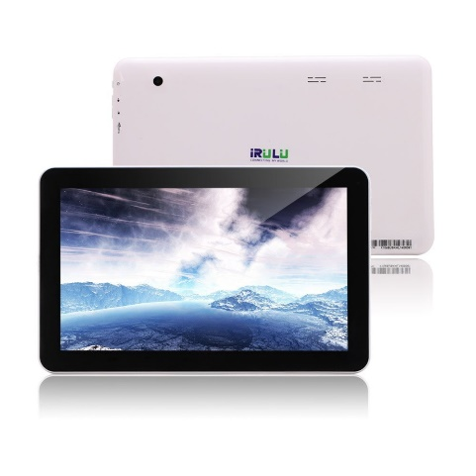
- Quad Core ARM Cortex-A7 CPU (4X1.3 GHZ)
- Android 5.1 Lollipop
- 10 inch 1024*600 HD touch screen
- 1 GB DDR3 RAM
- 8 GB NAND Flash ROM
- Dual camera (0.3MP front and 2MP rear)
- Wi-Fi (802.11 b,n,g)
- Bluetooth 4.0
- Up to 32GB Micro OUT OF STOCK!
$590.00

Dragon Touch A1X 10.1" Dual Core Tablet PC
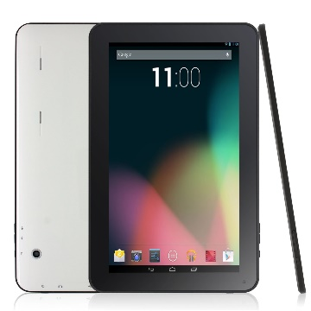
- Dual Core CPU Allwinner A23 up to 1.2GHz
- High-performance Quad Core Mali-400 GPU ensures smooth and
dynamic 3D graphics.
- Android 4.4 KitKat
- 1024x600 resolution
- 8GB NAND Flash
- Wi-Fi (802.11a/b/g/n)
$750.00

WARRANTY IS VOID IF THERE IS ANY PHYSICAL DAMAGE TO THE PRODUCT.

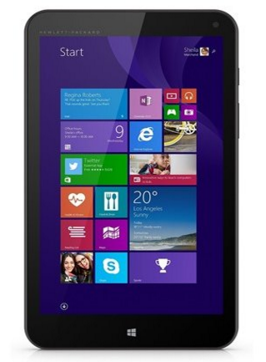
HP 5909 Stream 8 Tablet
- Windows 8.1 (32-Bit)
- 8" IPS WVA 1280 x 800 Multi-touch capacitive Screen
- Intel Atom Z3735 1.33GHz (Burst up to 1.83GHz) Quad-Core
- 1GB RAM
- 32GB Internal Memory, UP to 32GB MicroSD
- 802.11b/g/n
- Bluetooth 4.0 LE
- 2MP Front-Facing Camera, 5MP Rear-Facing Camera
$800.00
Tagital® 7" Phone Tablet
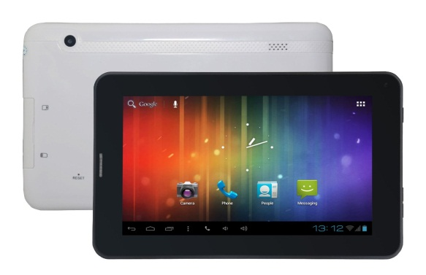
- 800 x 480 pixels High definition display screen
- Quad Core A33 1.2GHz CPU
- Android 4.4 OS
- Dual Cameras
- Wi-Fi (802.11a/b/g/n)
- Built-in 2G module, Supports Sim card
- Supports up to 32GB MicroSD
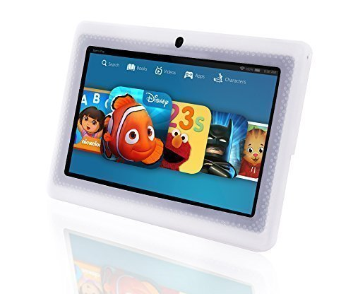
$495 (with FREE 8GB MICROSD)

LillyPad Jr.® Kids Tablet
- Android 4.4 KitKat
- 7 Inch Display Screen With 800x480 Resolution
- Dual camera
- Wi-Fi (802.11b/g/n), Bluetooth OUT OF STOCK!
$410.00
Hisense 8" Sero 8 Tablet
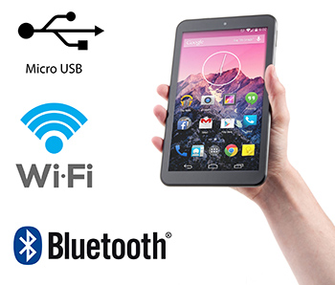
- Android KitKat 4.4
- 1.4GHz Cortex A9 Quad-Core Processor
- 8" Display Screen (1280 x 800 Resolution)
- 16GB Internal, 1GB DDR2 RAM
- 0.3 MP Front Camera, 2.0 MP Rear Camera
- WiFi, Bluetooth 3.0
- Up to 32GB MicroSD
- 7 hours Battery Life
$490.00 All Tablets have One (1) Month Warranty, WARRANTY IS VOID IF THERE IS ANY PHYSICAL DAMAGE TO THE PRODUCT.

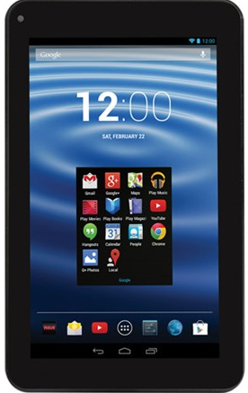
RCA 7" Tablet
- Android 4.4 OS (KitKat)
- 7" touchscreen, 1024 x 600 resolution
- 1GHz Dual-Core Processor
- 802.11b/g/n WiFi
- 2MP webcam (Rear); 0.3MP webcam (Front)
- 8GB Internal Storage
- Up to 4 hours of runtime on a full charge
$350.00

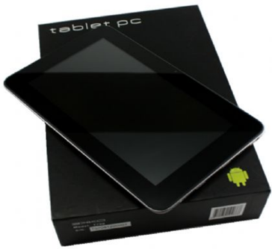
EKKO 7” Quad Core Tablet
- Android 4.2
- 8GB Up To 64GB
- ARM Cortex A7 Quad Core Processor
- 1024 x 600 HD Resolution
- 1GB DDR Memory
- Wi-fi, Front & Rear Facing Cameras
OUT OF STOCK!
$620.00

All Tablets have One (1) Month Warranty, WARRANTY IS VOID IF THERE IS ANY PHYSICAL DAMAGE TO THE PRODUCT.
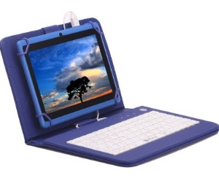
Accessories
Klip Extreme Generic Tablet Case
$30. 00 with Keyboard
$115.00 O/S!
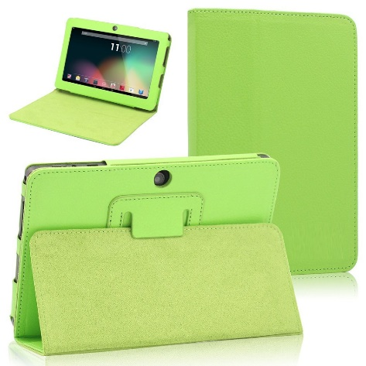
Klip Extreme Generic
$45.00 Tablet Case
$80.00

Klip Extreme
$30.00

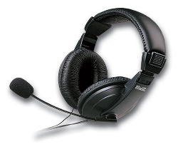
Klip Extreme
$60.00

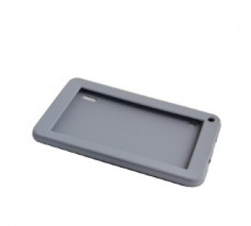

Ekko 7” Grey Tablet Cases $80.00

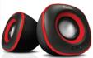

KlipX Stereo 2.0 Speakers $95.00
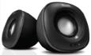

KlipX Stereo 2.0 Speakers $115.00

