#5 Harrinauth Street,El Dorado. Tel:662-1107/662-0455...Cell:739-0734.
PowerNetPC
Email: powernetpctt@yahoo.com
Wholesale Prices
Minimum Amount $1000
23/06/2016

MicroSD Flash Drives
Kingston Kingston
Class10 USB 2.0
(10 times faster than class 4) 8GB Flash Drive $28.00
4GB MicroSD $27.00 O/S 16GB Flash Drive $37.00
8GB MicroSD $32.00 32GB Flash Drive $70.00 O/S
16GB MicroSD $40.00 64GB Flash Drive $150.00
32GB MicroSD $65.00 USB 3.0
64GB MicroSD $300.00 8GB Flash Drive $30.00
Class4 16GB Flash Drive $35.00
4GB MicroSD $20.00 32GB Flash Drive $81.00
8GB MicroSD $32.00
16GB MicroSD $32.00
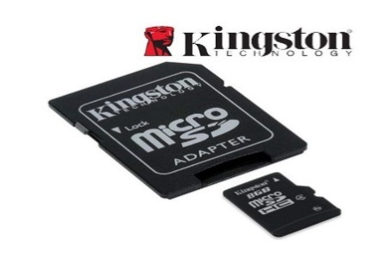
Kingston Duo Flash Drive
8GB Flash Drive $35.00
16GB Flash Drive $49.00
32GB Flash Drive $78.00
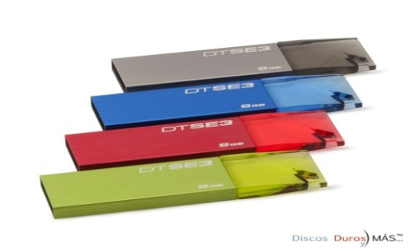
Kingston
4GB SD Card $32.00
SD Cards

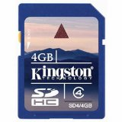
Sandisk
16GB Flash Drive $42.00
64GB MicroSD $210.00

